**Recursion**

* **Recursion Introduction:**

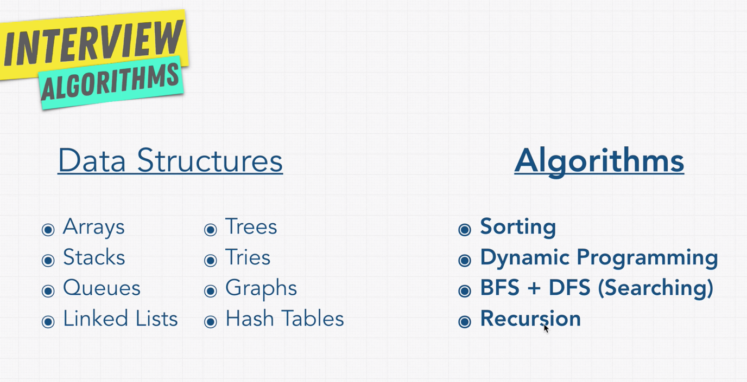

Note: Recursion is not an algorithm, it is a concept.

If I want to explore the files of the folder, if you open the root folder with ls command on (mac or unix like OS).

It will print the files and folders on that level, but it will not show the files under other folders. To get all the folders and file under a given root folder, we have to use ls -R , this R stands for Recursive.

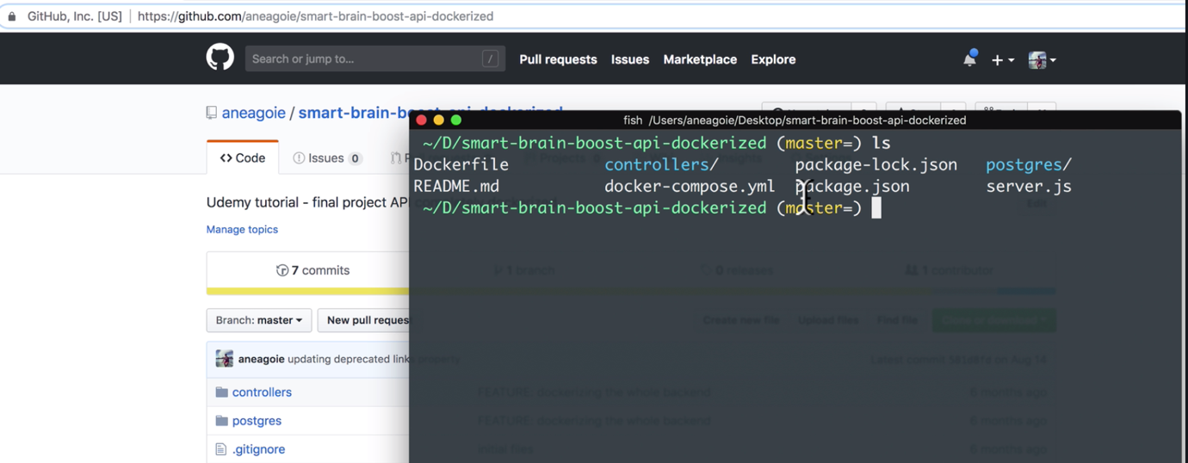

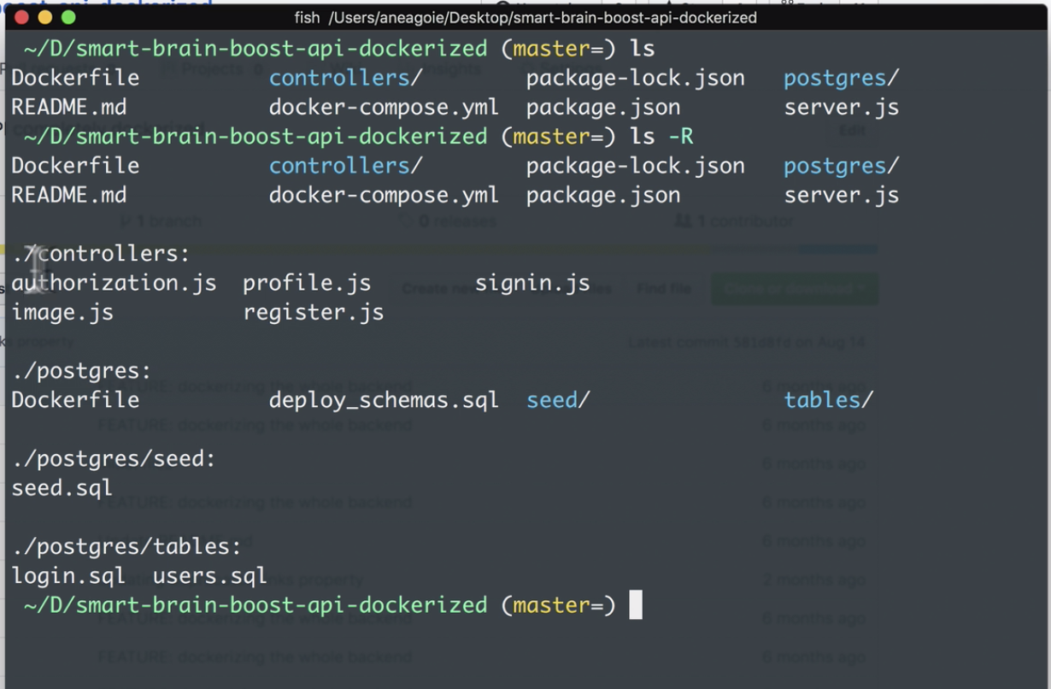

What is recursion?

Recursion is when you define something in terms of itself. Simply the function it refers to itself.

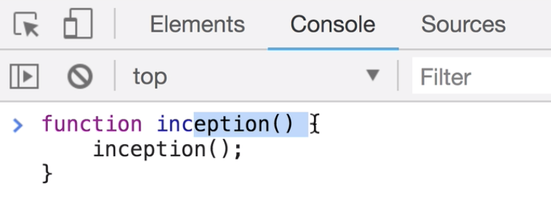

* **Stack Overflow:**

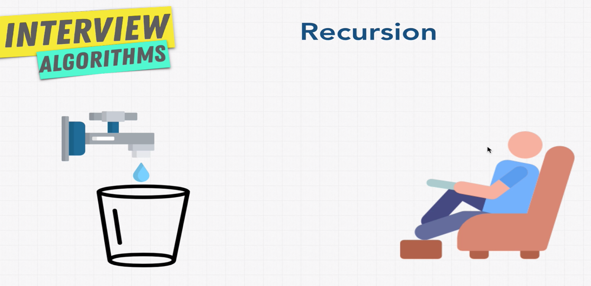

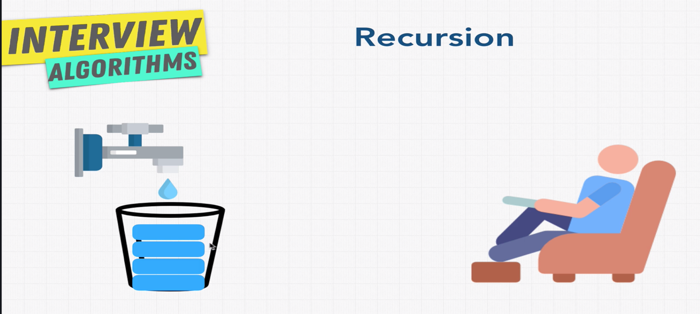

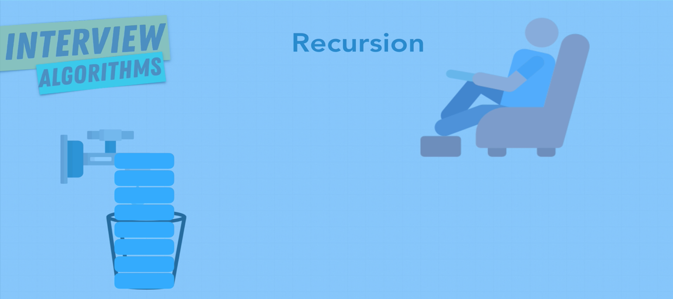

If we call above inception method on developer console, we will get the below result.

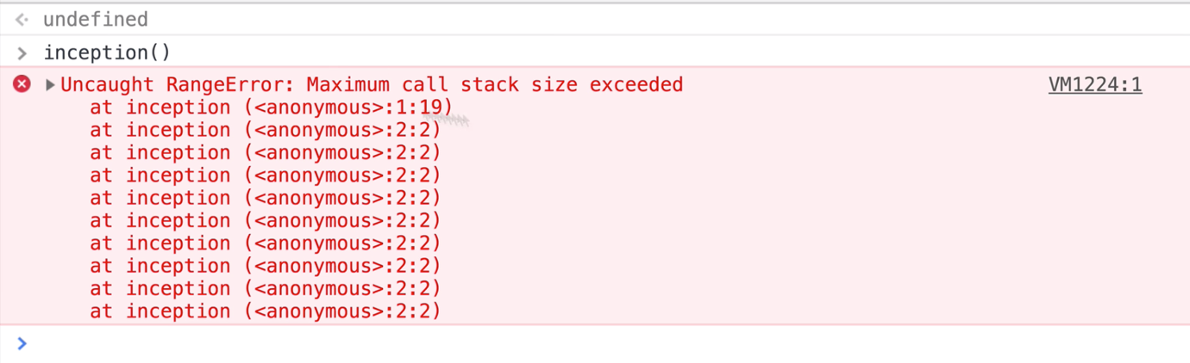

The browser has found that it will crash, so it throwed above error. If it is not handled the above function will crash the browser.

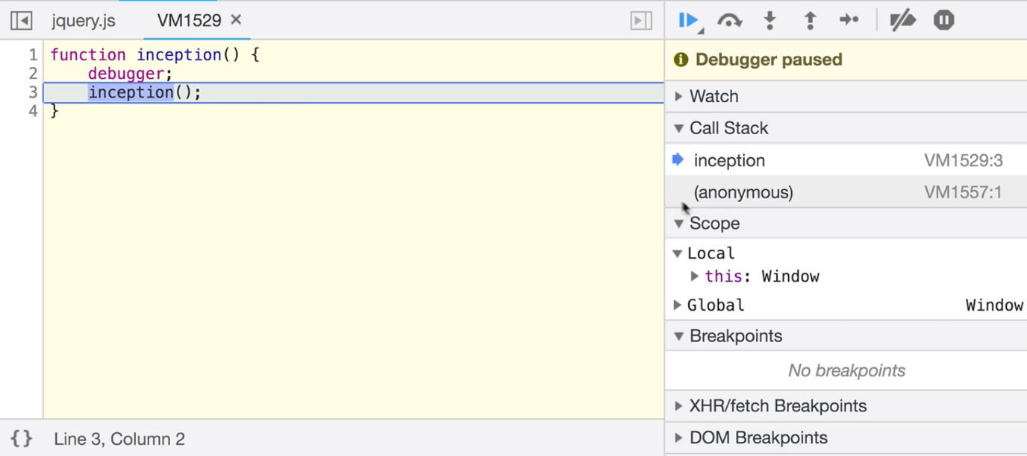

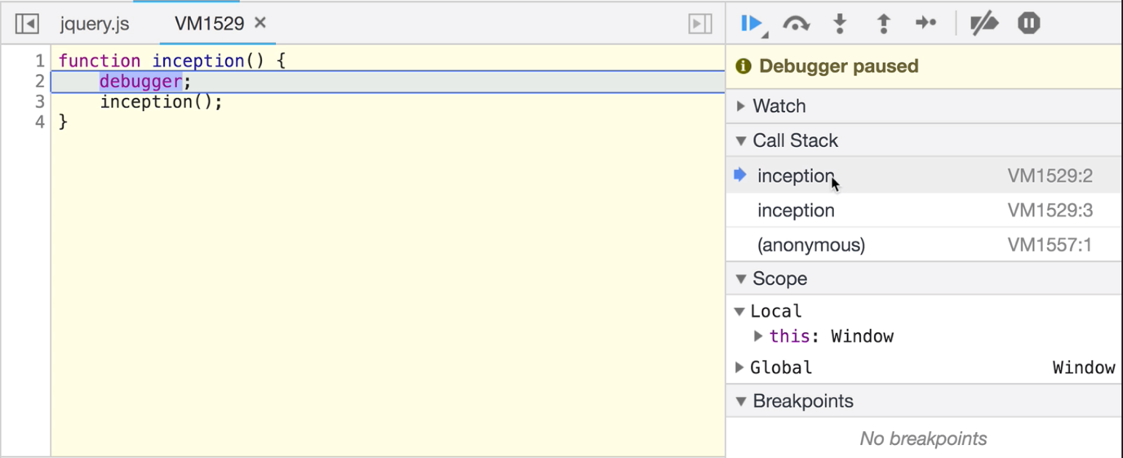

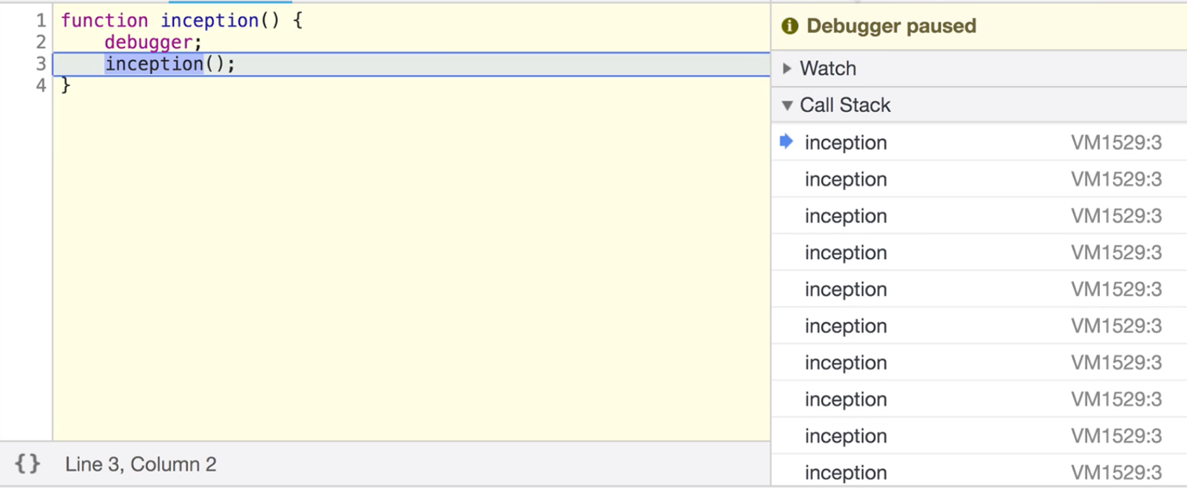

Stack overflow is the biggest problem in recursion.

* **Anatomy of Recursion:**

Every recursive function needs to have a base case / start point.

In our file/folder listing example, we have to tell the program, if the subfolder were going to no longer has any more folders stop.

If we don’t have this stop, the function will run endless.

Recursive function has two paths:

One is the recursive case that is call the function again and run it.

Then the base case, stop calling the function nothing to process any more.

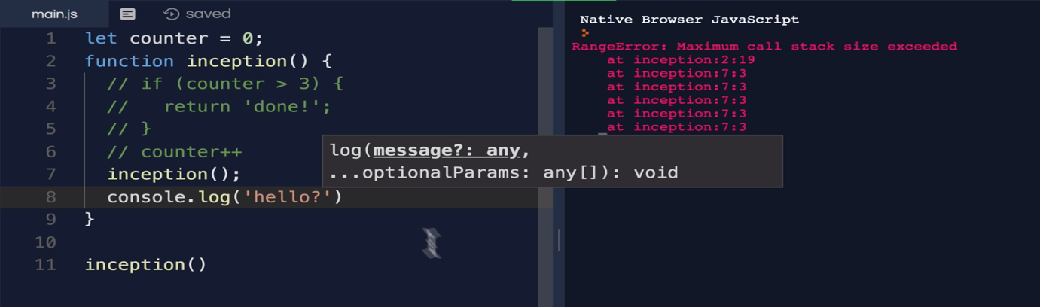

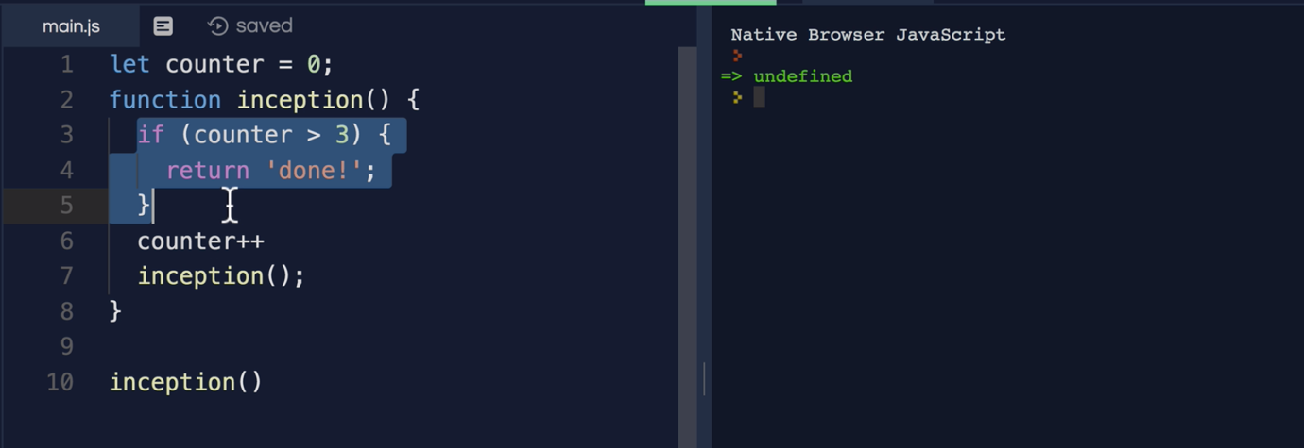

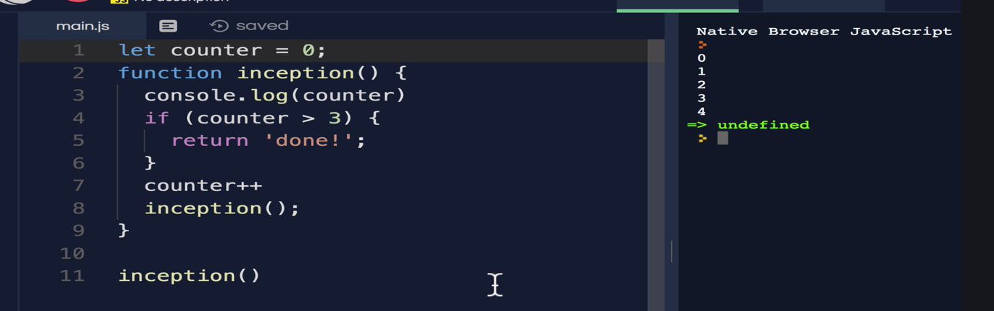

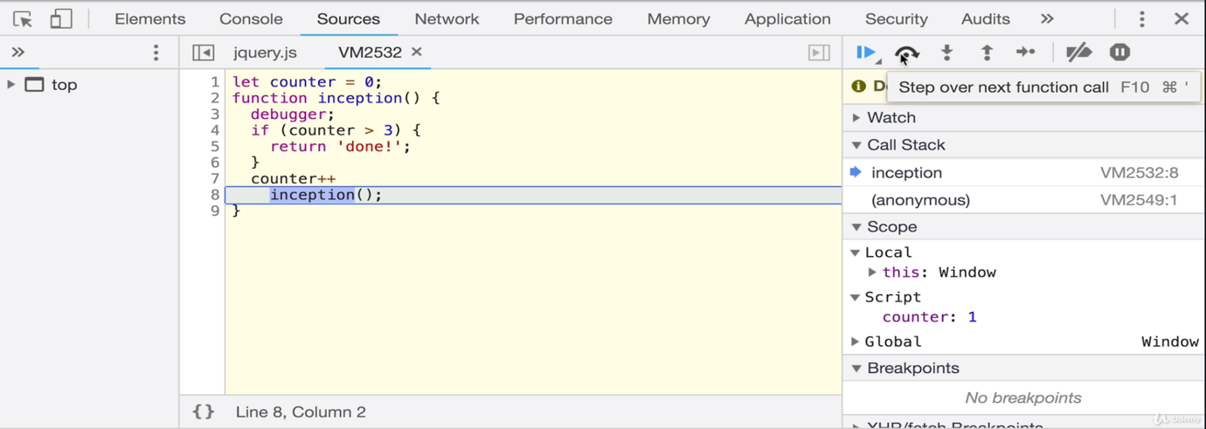

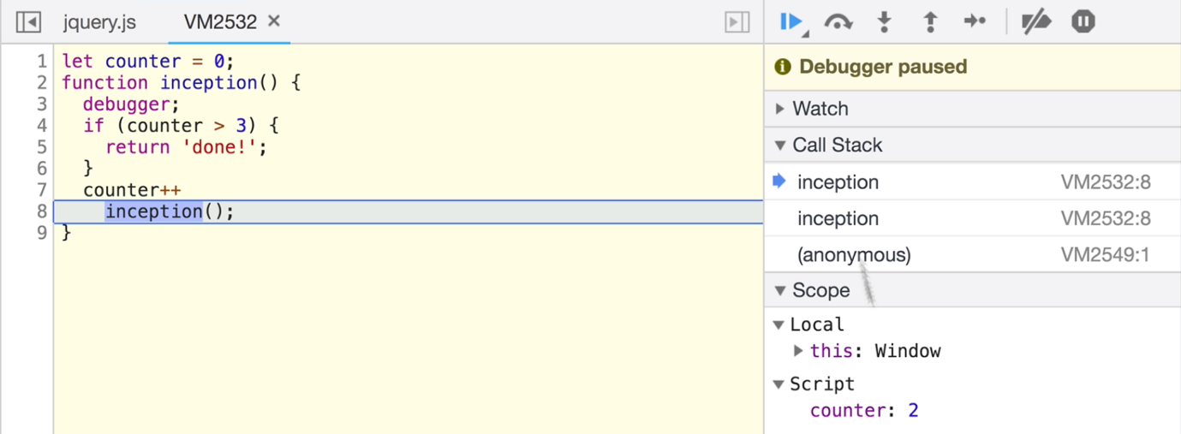

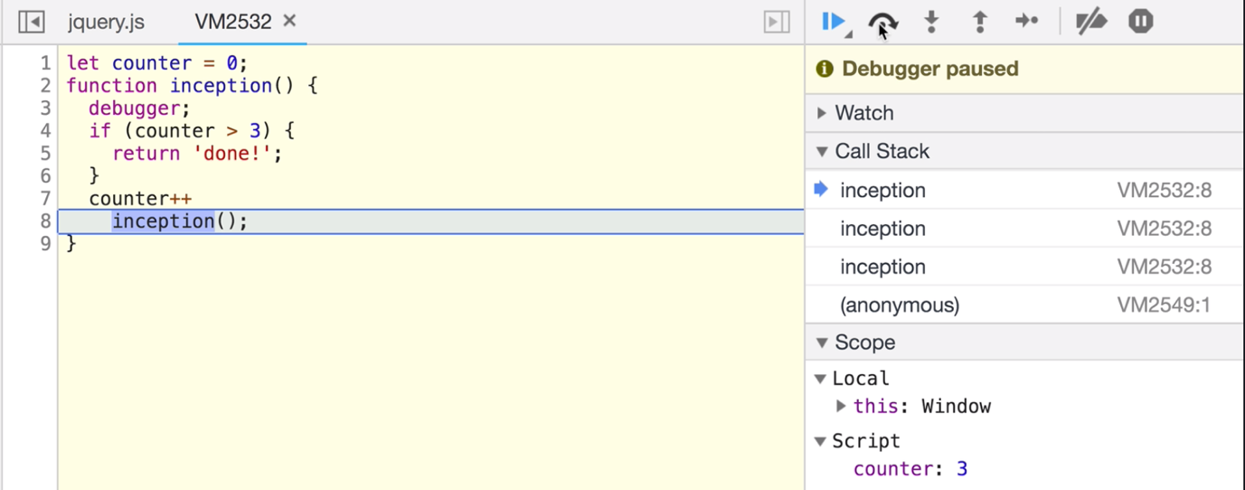

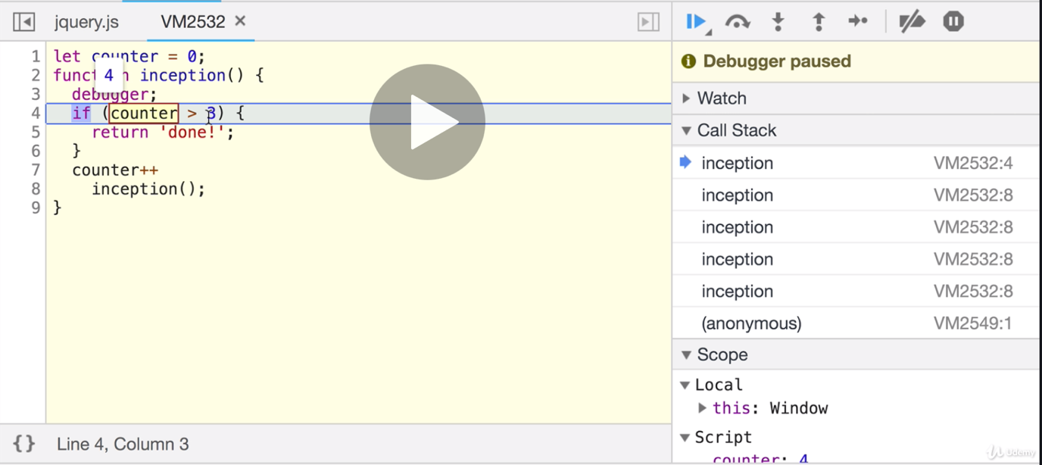

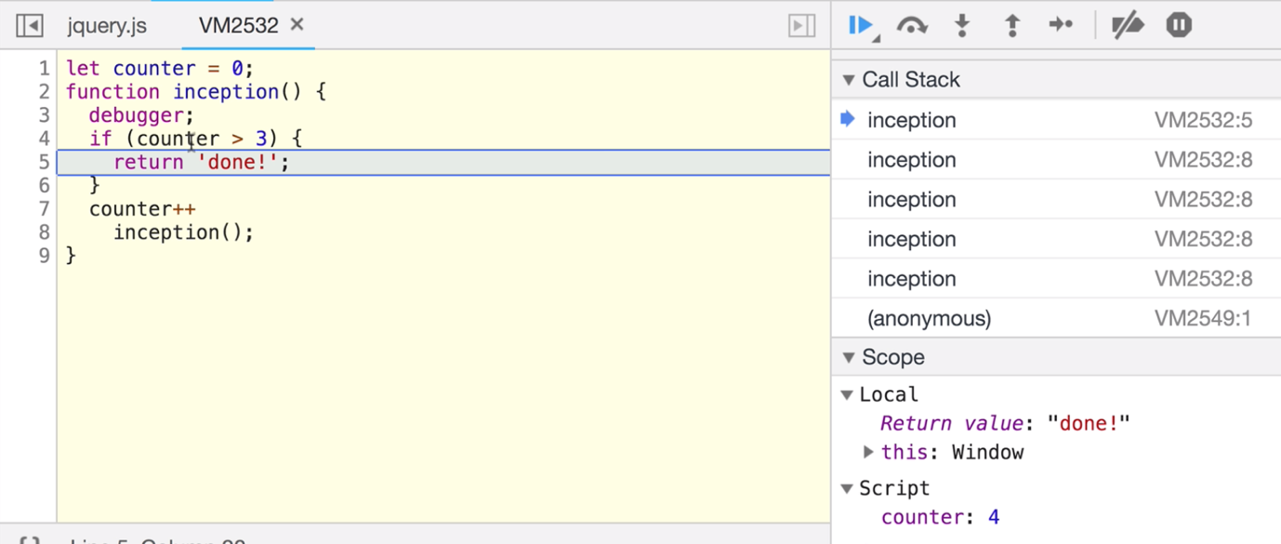

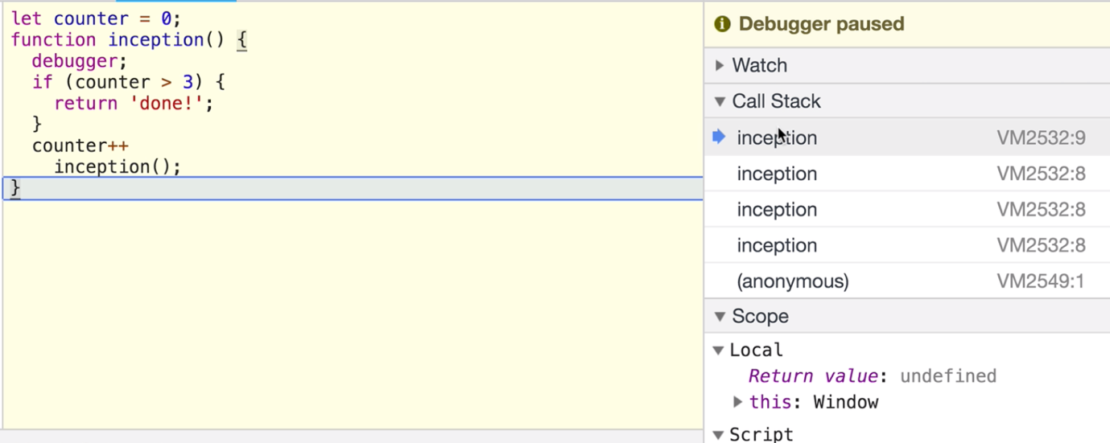

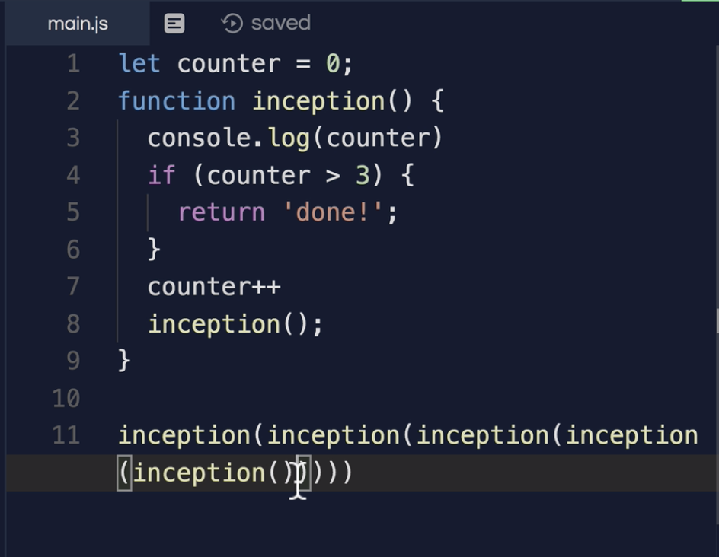

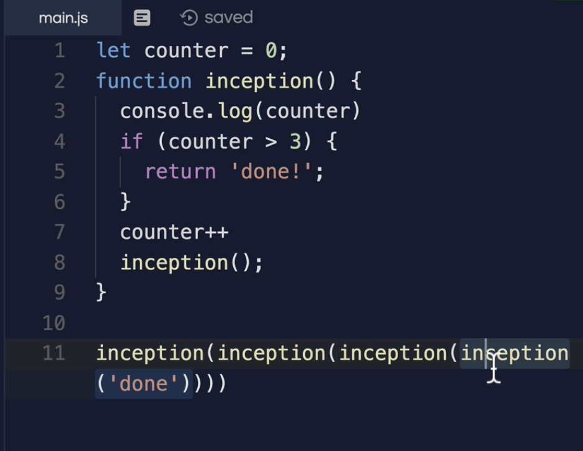

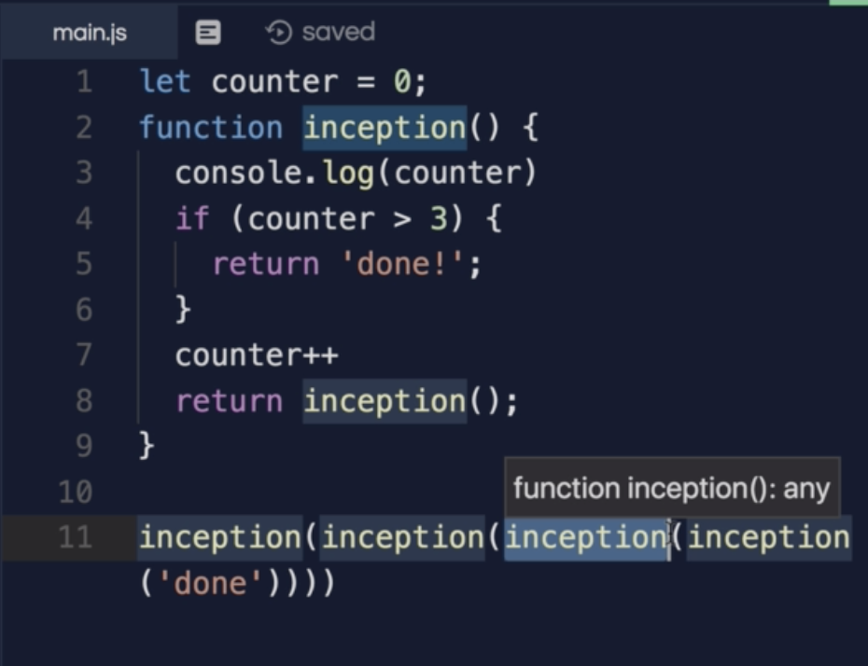

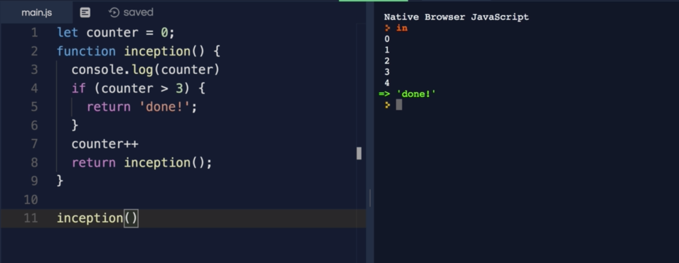

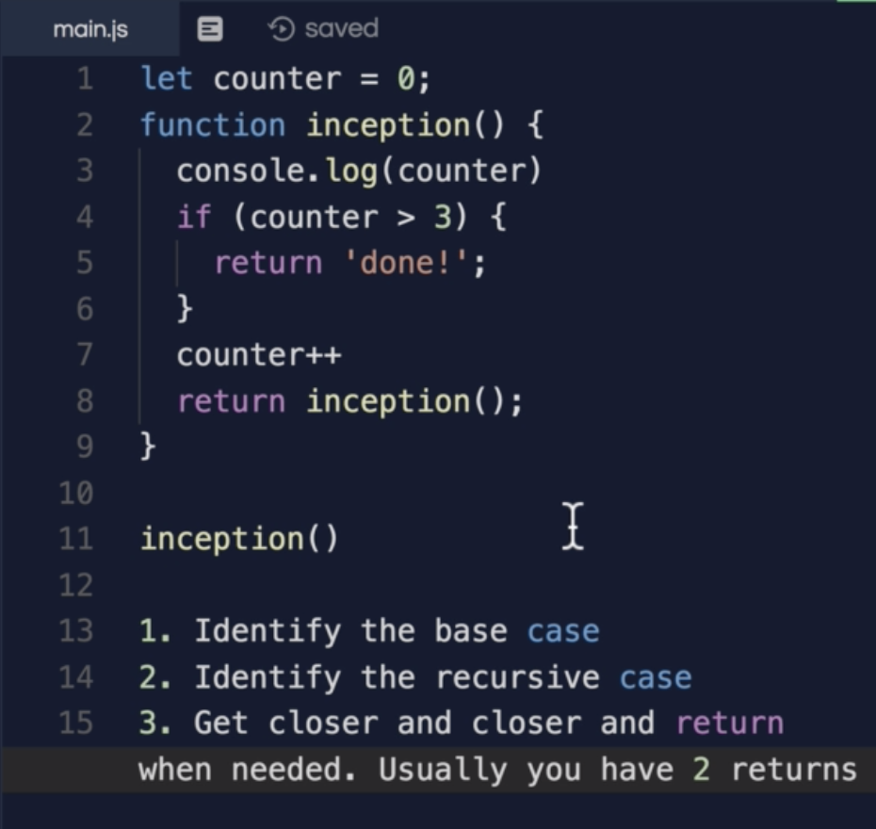

* **Recursive vs Iterative:**

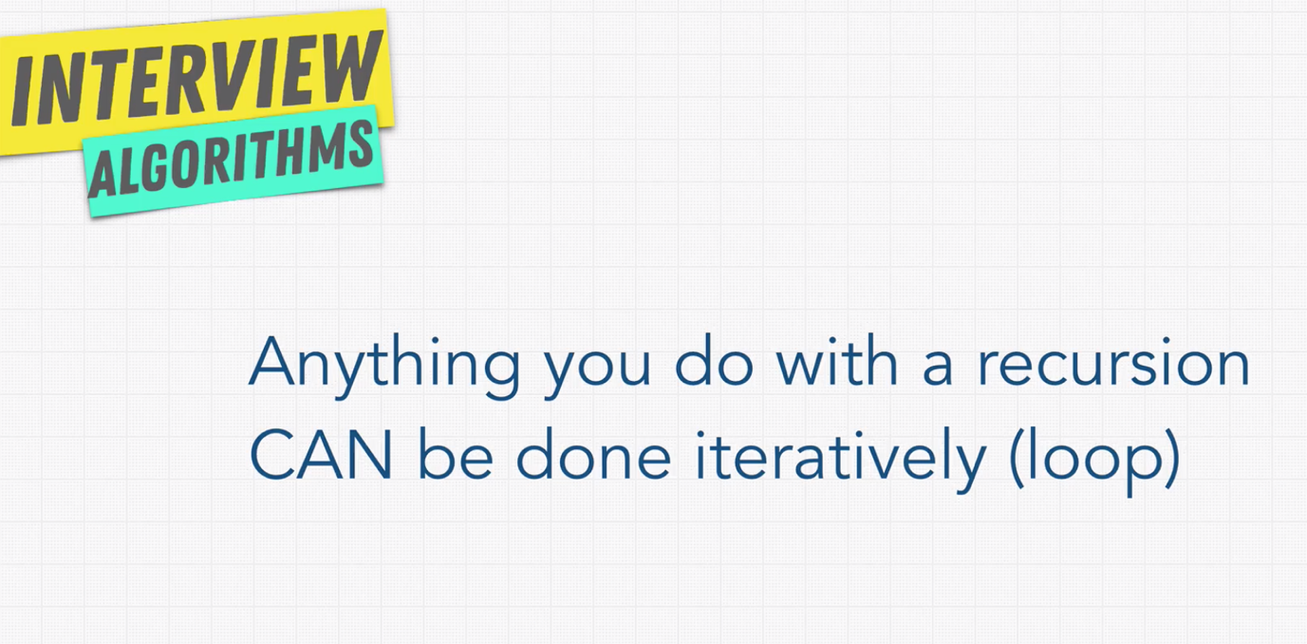

The main drawback of Recursion is that it will take more stack space, whereas iterative approach don’t eat up stack space.

Recursion will be a correct fit for the data structures which we don’t know how deep it goes, for example trees.

Note: In few programming languages there is some concept called, Tail call optimization for recursion, this feature don’t add up space for stack.

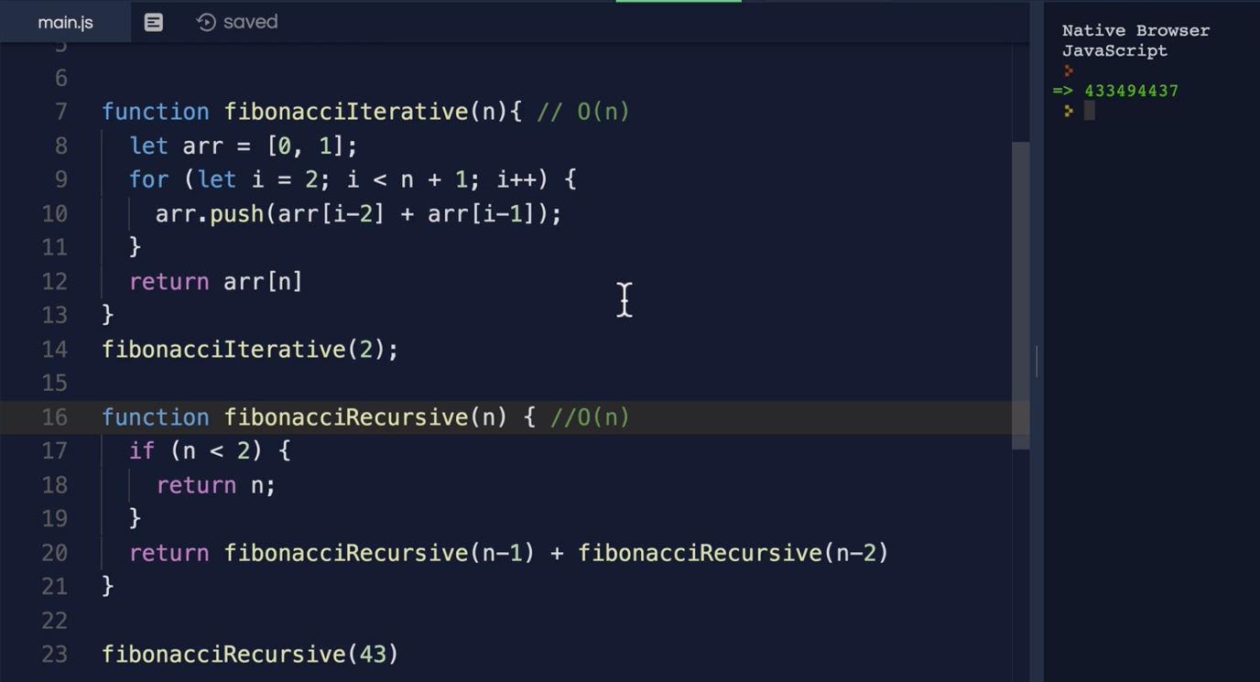

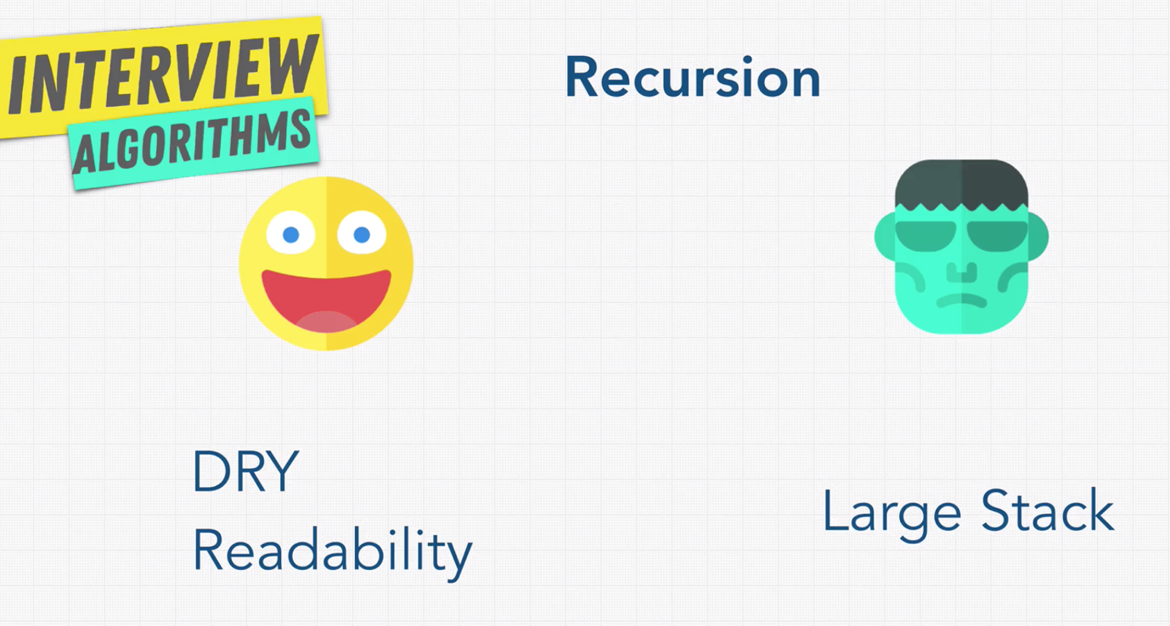

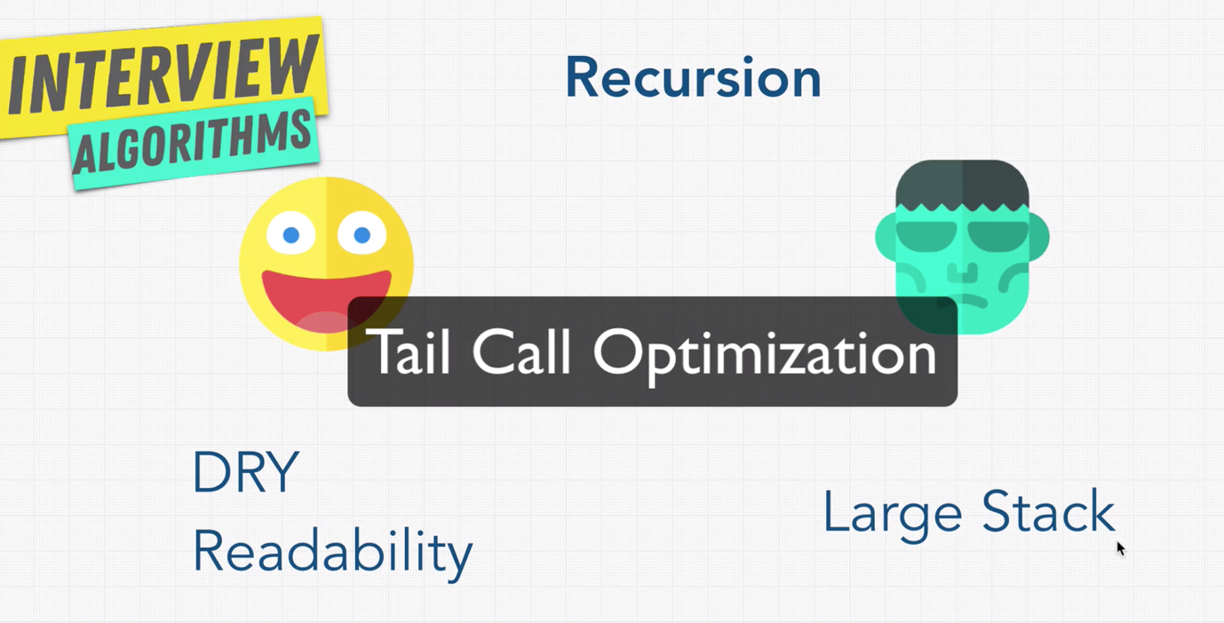

* **When to use Recursion:**

Recursion is mainly useful complicated problems like traversal/searching through trees or graphs.

For sorting some cases we use recursion.

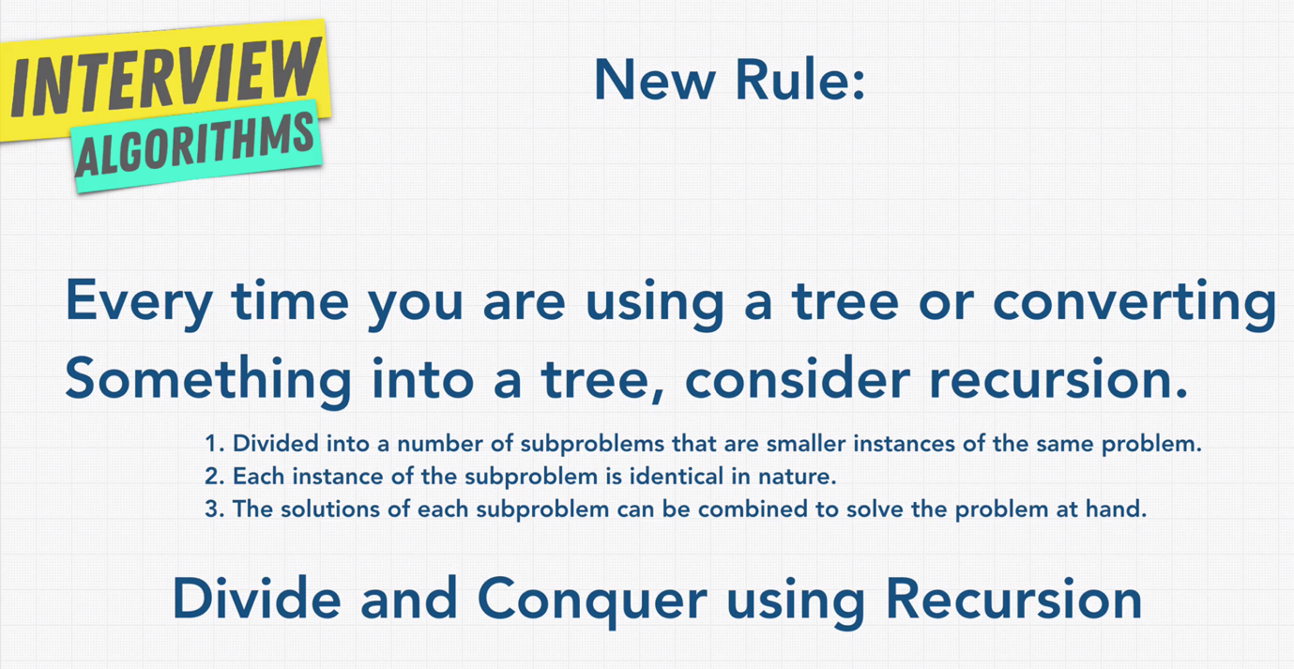

* **Recursion Review:**

